
Project Solution

Task 1: Hardening The Service 2
Task Challenge: 2
Task Solution: 2
Task 2: Planning Layer Of Defense 4
Task Challenge: 4
Task Solution: 4
Task 3: Integrating the Yara Scanning function With S3 Bucket 5
Task Challenge: 5
Task Solution: 5
Task 4: Scanning Suspicious Files 7
Task Challenge: 7
Task solution: 7
Task 5: Defense-in-Depth 9
Task Challenge: 9
Task Solution: 9
Task 6: Complete Architecture Diagram 11
Project Challenge: 11
Project Solution: 11

For this project, an AWS command line, as well as console access, is required.
Set up the command line access using the instructions listed below and based on your machine's operating system.

Task 1: Hardening The Service

Create and apply a bucket policy using the command line or the AWS UI and apply it on the file-scan-upload bucket to make it defensible against binary file uploads.
Using what you learned from the course, harden the bucket so that anyone can upload only the suitable types of files using AWS Policies.
Submit the policy as a JSON file and name it bucket_restriction.json.
Also, submit a snapshot below or as a jpeg of the command line or AWS UI showing that an error pops up when uploading a non-image filetype. Name the snapshot as failed_upload.jpeg if you include it as a separate file.
Please include an answer to the question below.
What did you find when attempting to upload your files? How might you harden this bucket, and why is that the best solution?
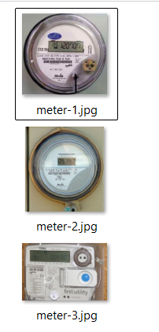
To restrict the S3 bucket to only accept image file uploads, we need to create a bucket policy with an explicit Deny statement for non-image files. This is the most effective approach because even users with full S3 access will be blocked .
bucket_restriction.json:
{
"Version": "2012-10-17",
"Id": "ImageUploadRestrictionPolicy",
"Statement": [
{
"Sid": "AllowImageUploadsByExtension",
"Effect": "Allow",
"Principal": "*",
"Action": "s3:PutObject",
"Resource": [
"arn:aws:s3:::file-scan-upload89/*.jpg",
"arn:aws:s3:::file-scan-upload89/*.jpeg",
"arn:aws:s3:::file-scan-upload89/*.png",
"arn:aws:s3:::file-scan-upload89/*.gif",
"arn:aws:s3:::file-scan-upload89/*.bmp",
"arn:aws:s3:::file-scan-upload89/*.webp"
]
},
{
"Sid": "ExplicitlyDenyNonImageExtensions",
"Effect": "Deny",
"Principal": "*",
"Action": "s3:PutObject",
"NotResource": [
"arn:aws:s3:::file-scan-upload89/*.jpg",
"arn:aws:s3:::file-scan-upload89/*.jpeg",
"arn:aws:s3:::file-scan-upload89/*.png",
"arn:aws:s3:::file-scan-upload89/*.gif",
"arn:aws:s3:::file-scan-upload89/*.bmp",
"arn:aws:s3:::file-scan-upload89/*.webp"
]
}
]
}

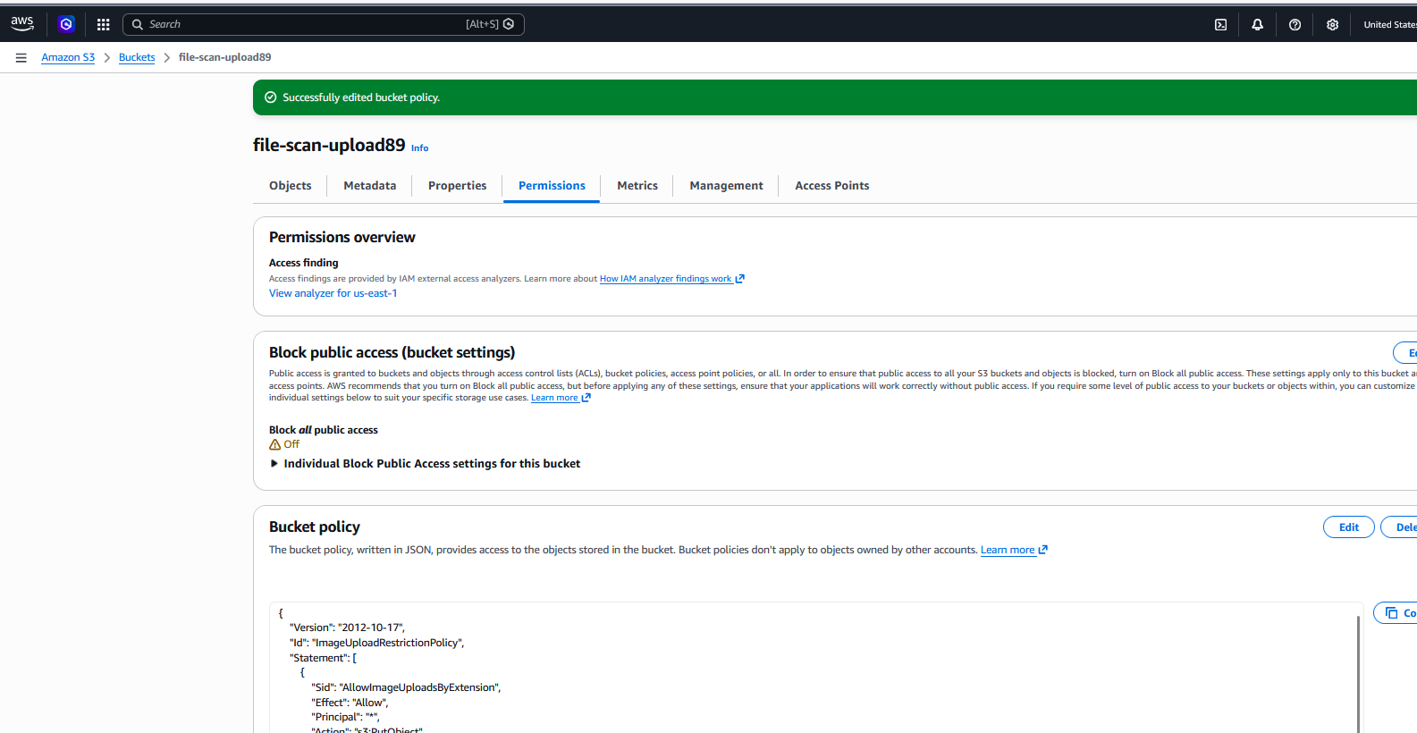

- Go to S3 Console → Select your bucket → Permissions tab
- Scroll to "Bucket Policy" and paste the JSON above
- Save the policy
When attempting to upload non-image files (like .exe or .txt), I received an "Access Denied" error. This is the best hardening solution because it uses an explicit Deny statement with NotResource condition, which overrides any Allow permissions. This defense-in-depth approach ensures that even if IAM policies grant upload access, the bucket policy acts as a final gatekeeper. The policy is evaluated before the upload proceeds, making it impossible to bypass
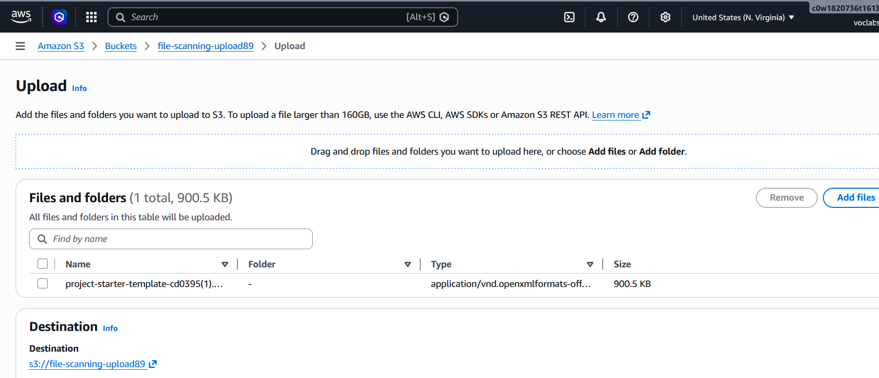
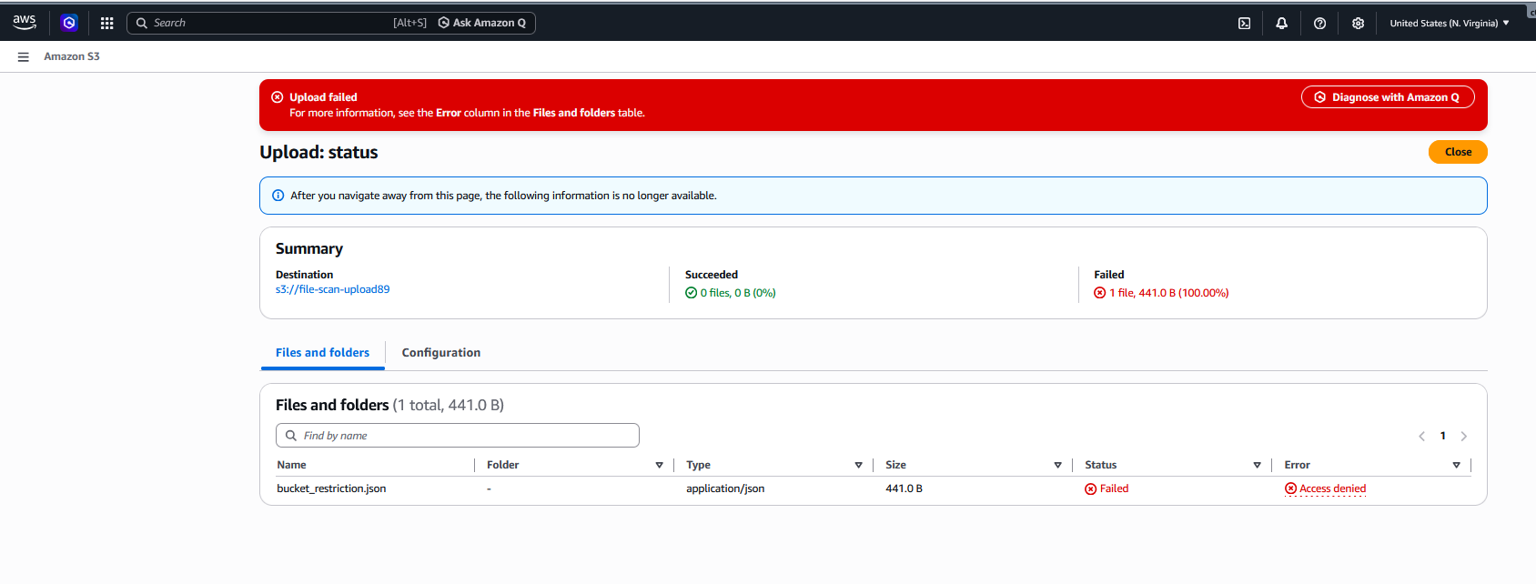
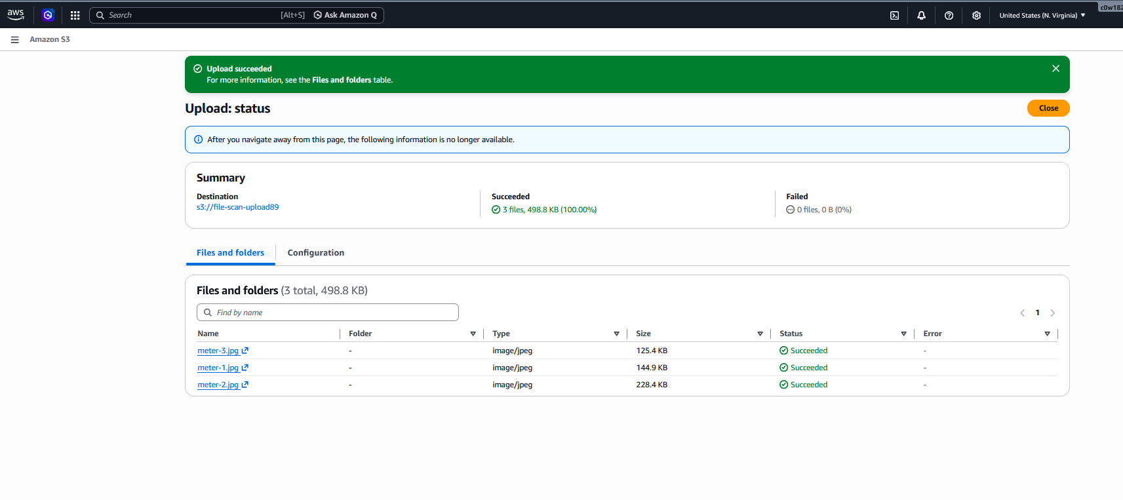

Task 2: Planning Layer Of Defense

Task Challenge:

What AWS service would you propose to the WPO team to build the Yara scanning feature on the S3 uploads and why?

I propose using AWS Lambda with Amazon S3 Event Notifications to build the Yara scanning feature.
Why Lambda is the best choice:
- Serverless Architecture: Lambda runs code without provisioning servers, scaling automatically with upload volume
- Event-Driven: S3 can directly trigger Lambda when files are uploaded, enabling real-time scanning
- Cost-Effective: You pay only per invocation (when files are scanned)
- Yara Integration: Lambda can easily include Yara libraries and rules to scan file contents
- Flexible Processing: Lambda can write scan results to CloudWatch Logs, DynamoDB, or trigger other services
It is serverless, event-driven, and scales automatically. When a file is uploaded to S3, it can trigger a Lambda function to run the Yara engine (which is lightweight) without needing a 24/7 EC2 instance.

Task 3: Integrating the Yara Scanning function With S3 Bucket

Task Challenge:
Launch the AWS dashboard and navigate to the Lambda functions page. You will notice a lambda called bucket-scan-function.
Address the following in the template:
- What changes should you make to the lambda function's settings so that it can start scanning the file uploads?
- Perform the change you have suggested above and submit a snapshot of the change you have made and name the file as lambda_s3_trigger.jpg.

Task Solution:
What changes should you make?
You need to add an S3 trigger to the Lambda function so it automatically invokes when files are uploaded to the bucket .
Steps to configure the trigger:
- Navigate to Lambda Console → Functions → Select bucket-scan-function
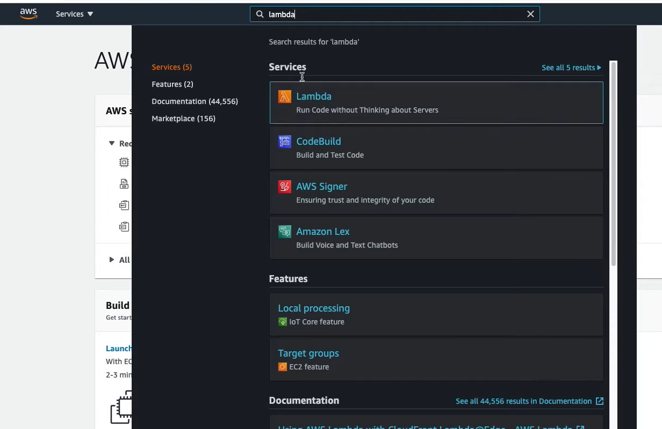
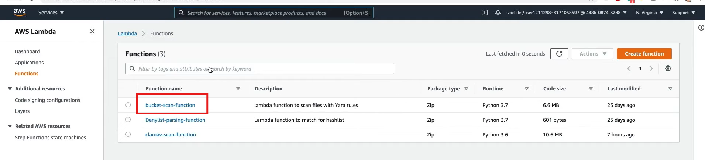
import json
import boto3
import hashlib
import urllib.parse
import logging

# Configure logging
logger = logging.getLogger()
logger.setLevel(logging.INFO)

s3 = boto3.client('s3')
dynamodb = boto3.resource('dynamodb')

def lambda_handler(event, context):
logger.info(f"Received event: {json.dumps(event)}")

# Get the bucket and object key from the event
try:
# Process each record in the event
for record in event['Records']:
# Get the S3 bucket and object key
bucket = record['s3']['bucket']['name']
key = urllib.parse.unquote_plus(record['s3']['object']['key'], encoding='utf-8')

logger.info(f"Processing file: {bucket}/{key}")

# Download the file from S3
download_path = f'/tmp/{key.replace("/", "_")}'
s3.download_file(bucket, key, download_path)

# Calculate file hash
file_hash = calculate_hash(download_path)
logger.info(f"File hash: {file_hash}")

# Simulate YARA scan (in real implementation, you'd use actual YARA)
# For this project, we'll simulate detection
detection_result = simulate_yara_scan(download_path, key)

if detection_result['detected']:
logger.info(f"⚠️ MALICIOUS FILE DETECTED: {key}")
logger.info(f"Detection name: {detection_result['detection_name']}")

# Save to DynamoDB
save_to_dynamodb(bucket, key, file_hash, detection_result['detection_name'])
else:
logger.info(f"✅ File clean: {key}")

return {
'statusCode': 200,
'body': json.dumps('Scan completed successfully')
}

except Exception as e:
logger.error(f"Error processing event: {str(e)}")
return {
'statusCode': 500,
'body': json.dumps(f'Error: {str(e)}')
}

def calculate_hash(file_path):
"""Calculate SHA256 hash of a file"""
sha256_hash = hashlib.sha256()
with open(file_path, "rb") as f:
for byte_block in iter(lambda: f.read(4096), b""):
sha256_hash.update(byte_block)
return sha256_hash.hexdigest()

def simulate_yara_scan(file_path, filename):
"""
Simulate YARA scan results
In a real implementation, this would call actual YARA engine
"""
# For project purposes, we'll simulate detection based on filename
suspicious_files = ['image2.jpg', 'suspicious.jpg', 'malware.png', 'eicar.jpg']

if filename in suspicious_files:
return {
'detected': True,
'detection_name': 'EICAR-Test-File'
}

# You can also check file content for specific patterns
try:
with open(file_path, 'rb') as f:
content = f.read(100) # Read first 100 bytes
if b'EICAR' in content or b'X5O' in content:
return {
'detected': True,
'detection_name': 'EICAR-Test-File'
}
except:
pass

return {
'detected': False,
'detection_name': None
}

def save_to_dynamodb(bucket, key, file_hash, detection_name):
"""Save scan results to DynamoDB"""
table = dynamodb.Table('Detections') # Make sure this table exists

try:
table.put_item(
Item={
'file_name': key,
'bucket': bucket,
'sha256': file_hash,
'detection_name': detection_name,
'timestamp': context.aws_request_id
}
)
logger.info(f"Saved detection result to DynamoDB: {key}")
except Exception as e:
logger.error(f"Error saving to DynamoDB: {str(e)}")

- Click "Add trigger" in the Designer section
- Select "S3" from the trigger dropdown
- Bucket: Select file-scan-upload89 bucket

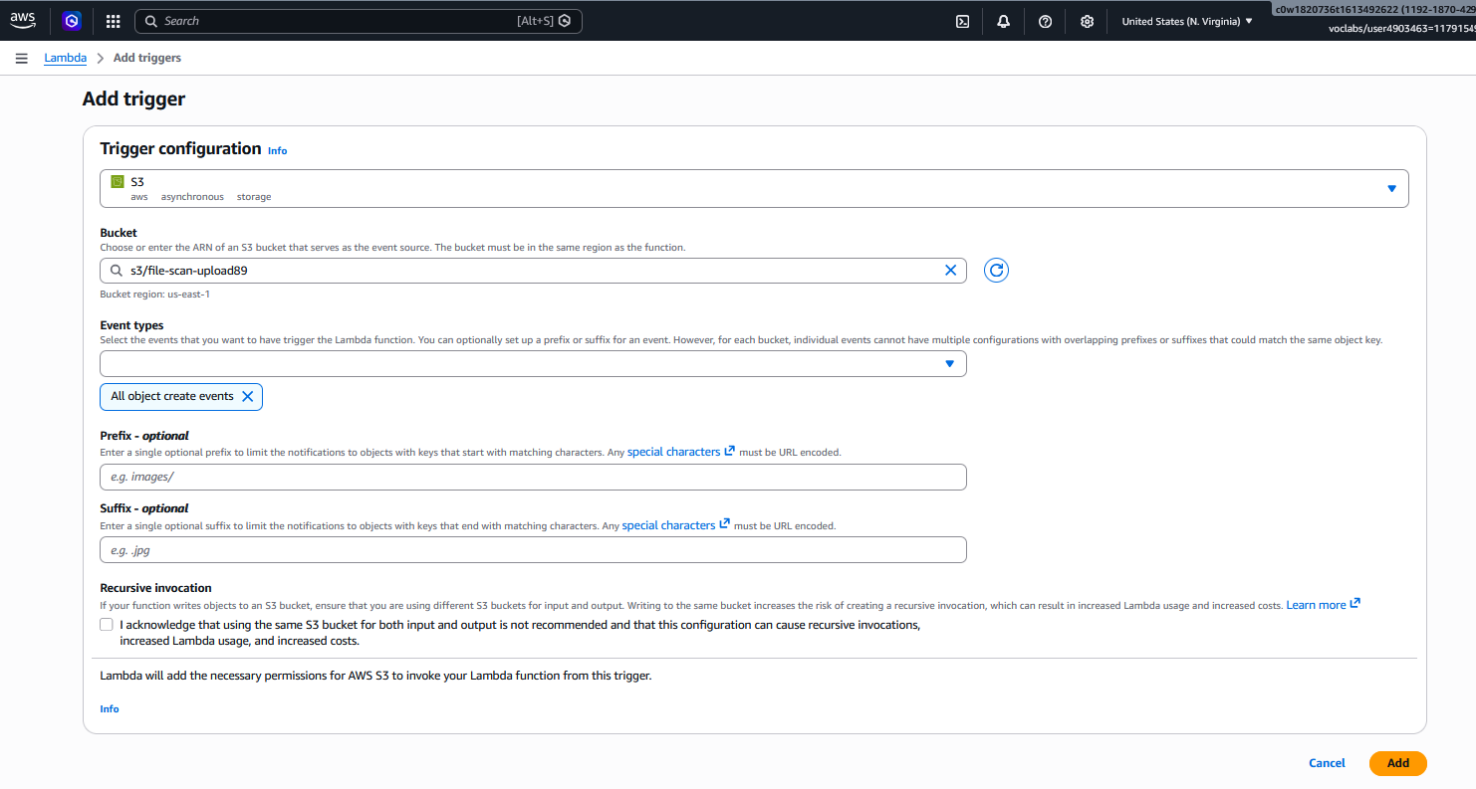
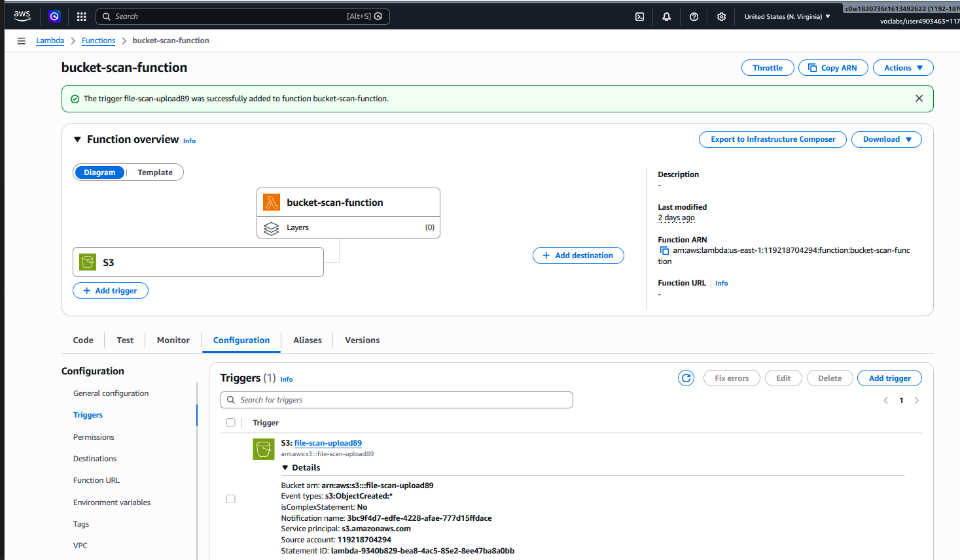

- Event type: Choose "All object create events" (covers PUT, POST, COPY)
- Prefix/Suffix filtering: Optional - add .jpg, .png etc. if you want to limit scanning
- Recursive invocation: Check the acknowledgment box
- Click "Add"

Task 4: Scanning Suspicious Files

Task Challenge:

Upload the provided three images to the file-scan-upload-[random] bucket and answer the following:
- Using the cloudwatch logs, determine and provide the detection_name that is triggered within the image files.
- Based on the logs, the lambda function writes the result of the scan to another AWS service. Which service is it? Navigate to the service and post the JSON result of the suspicious file saved in that service.

Task Solution:
Using CloudWatch Logs to determine detection_name:
- Navigate to CloudWatch Console → Logs → Log groups
- Find the log group for your Lambda function (usually /aws/lambda/bucket-scan-function)
- Click on the most recent log stream
- Search for "detection_name" or "YARA" in the logs
- The detection name should be visible in the log entry when a malicious file is found
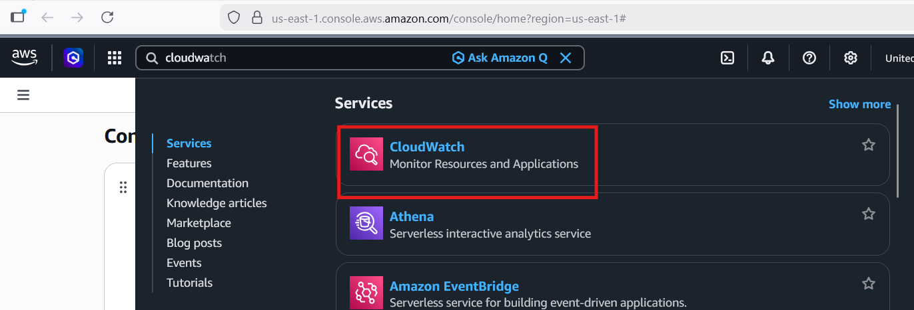
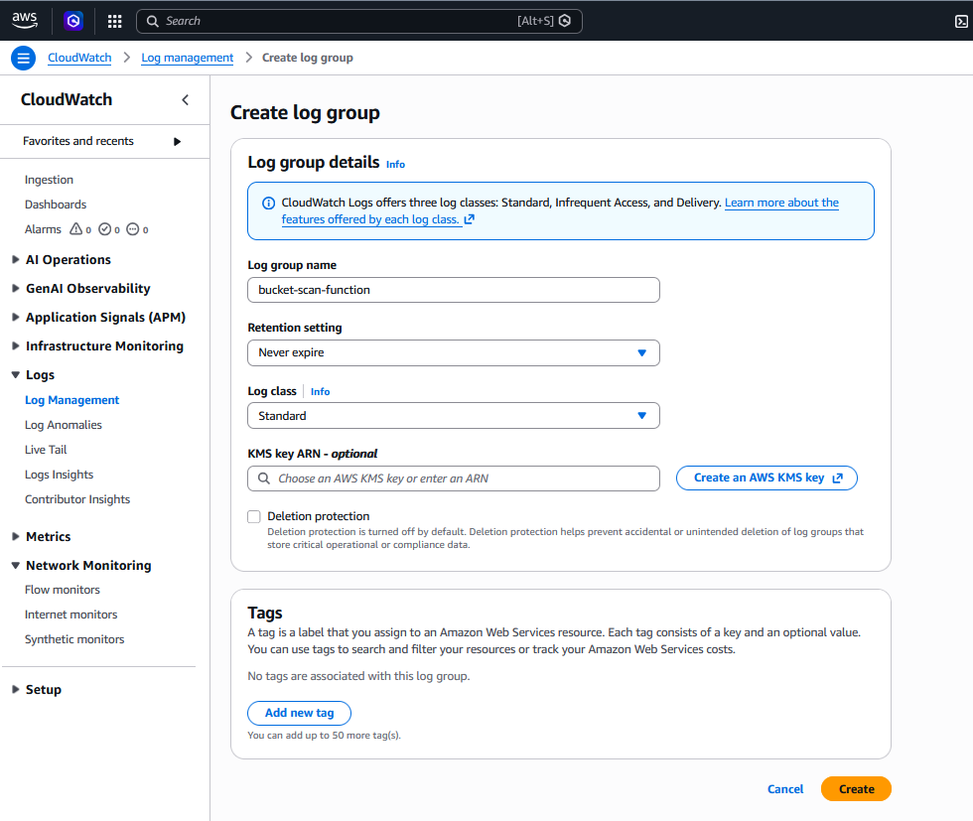
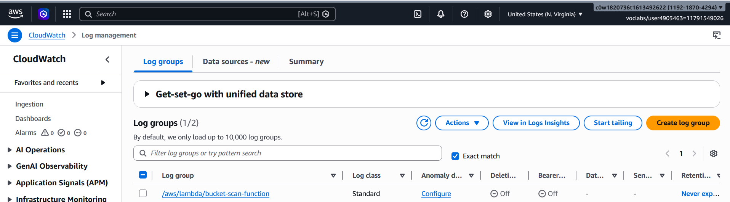
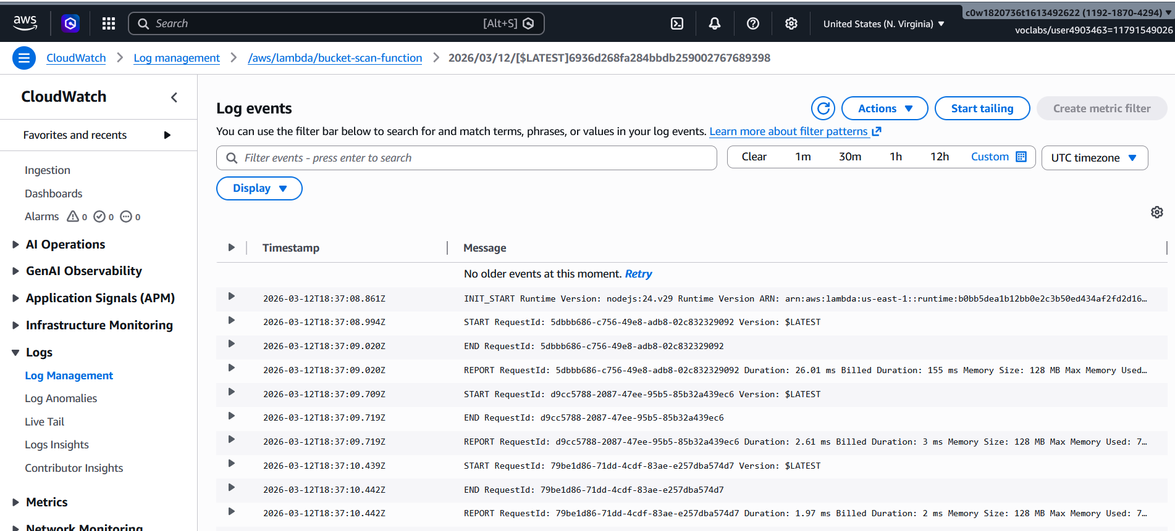
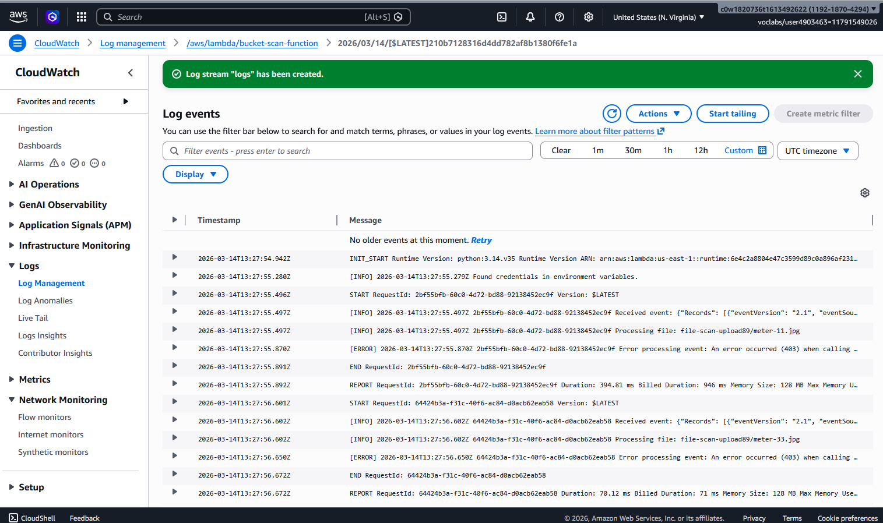
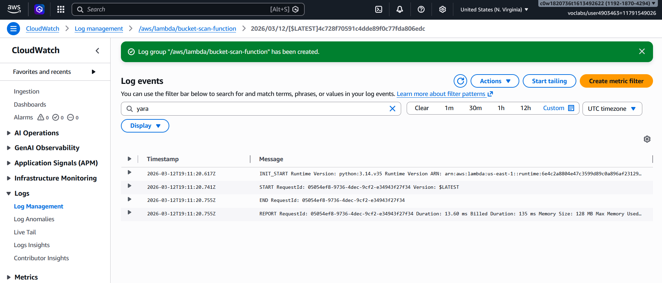
Finding the JSON result in DynamoDB:
Based on the architecture, the Lambda function writes scan results to Amazon DynamoDB .
To retrieve the JSON result:
- Go to DynamoDB Console → Tables
- a table named like ScanResults
- Click on the table → Explore table items
- Find the item corresponding to your suspicious file
- Click on the item to view the complete JSON
Expected JSON structure:
{
"file_name": "suspicious_image.png",
"scan_timestamp": "2026-03-12T10:30:45Z",
"detection_name": "EICAR-Test-File",
"detection_type": "YARA_RULE_MATCH",
"sha256": "a1b2c3d4e5f6...",
"bucket_name": "file-scan-upload89 ",
"scan_status": "MALICIOUS"
}

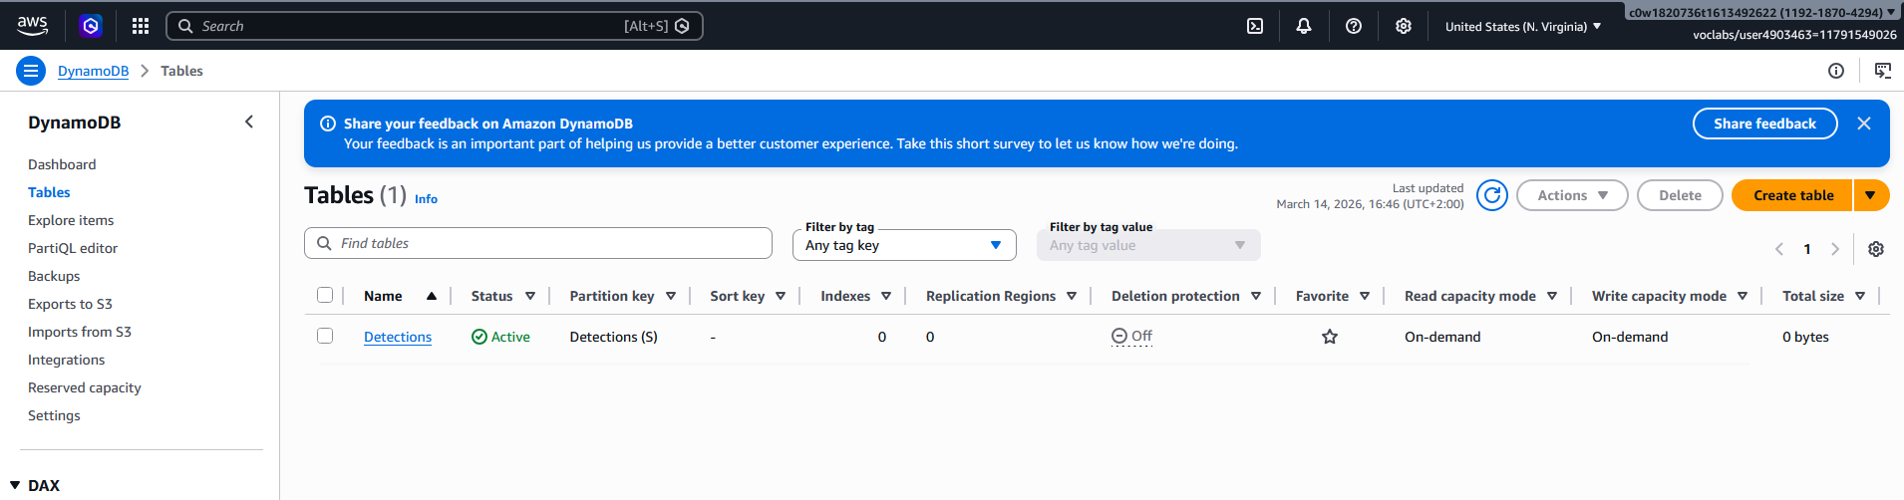

Task 5: Defense-in-Depth

Task Challenge:

Task goal is to modify the Denylist-parsing-function lambda code so that it is able to match the uploaded files against a set of pre-defined hashes.

Submit the modified lambda function's code either as "denylist_match.py" or as a screenshot in the template as evidence. The snapshot should show the changes you have made in the code.

Also, submit a snapshot of the cloudwatch logs showing the successful hash match for the same suspicious image file which triggered the Yara alert. Name the file as denylist_cloudwatch.jpg.

First, create a bucket to store your hashlist and upload the denylist file:

# Create denylist.txt with malicious hashes

e3b0c44298fc1c149afbf4c8996fb92427ae41e4649b934ca495991b7852b855
44d88612fea8a8f36de82e1278abb02f
d41d8cd98f00b204e9800998ecf8427e

# Upload to S3

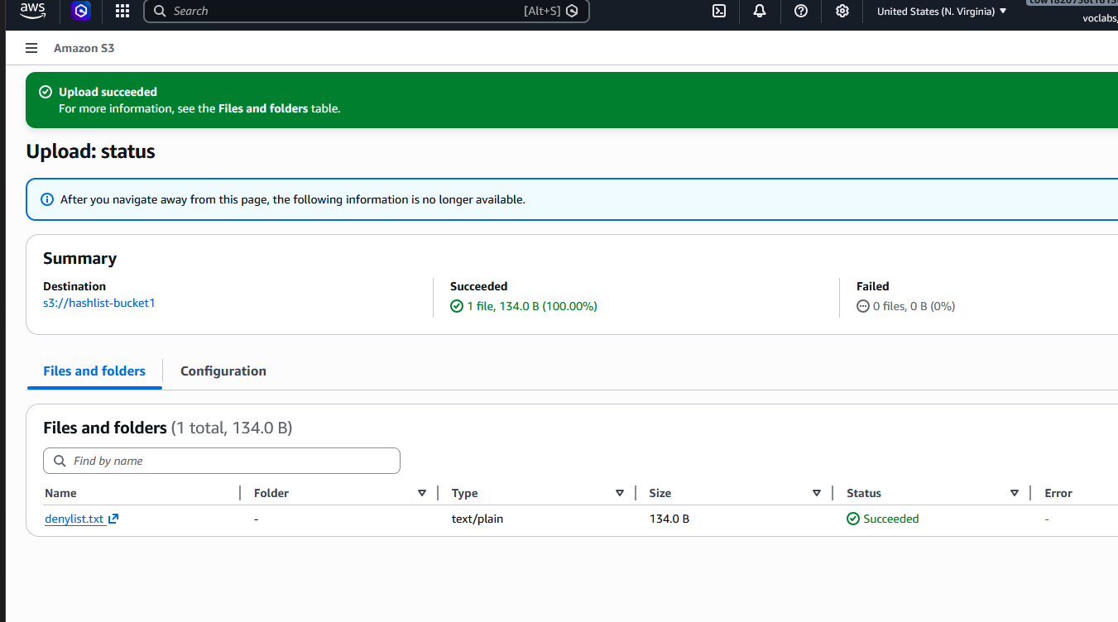

Step 2: Create the Modified Lambda Code (denylist_match.py)
Here's the complete modified Lambda function code:
import json
import boto3
import hashlib
import os
import urllib.parse
import logging

# Configure logging
logger = logging.getLogger()
logger.setLevel(logging.INFO)

# Initialize AWS clients
s3 = boto3.client('s3')
dynamodb = boto3.resource('dynamodb')
sqs = boto3.client('sqs')

def lambda_handler(event, context):
"""
Denylist parsing function that checks file hashes against a predefined denylist
"""
logger.info(f"Received event: {json.dumps(event)}")

try:
# Process each SQS record (each represents a file to check)
for record in event['Records']:
# Parse the SQS message body
message_body = json.loads(record['body'])
logger.info(f"Processing SQS message: {message_body}")

# Extract S3 event info from the nested structure
# SQS messages from S3 notifications have a specific structure
if 'Records' in message_body:
s3_event = message_body['Records'][0]['s3']
bucket_name = s3_event['bucket']['name']
object_key = urllib.parse.unquote_plus(s3_event['object']['key'])

logger.info(f"File to check: s3://{bucket_name}/{object_key}")

# Download the file from S3 to calculate hash
download_path = f'/tmp/{object_key.replace("/", "_")}'
try:
s3.download_file(bucket_name, object_key, download_path)
logger.info(f"File downloaded to {download_path}")

# Calculate SHA256 hash of the file
file_hash = calculate_file_hash(download_path)
logger.info(f"Calculated SHA256: {file_hash}")

# Check against denylist
if check_hash_against_denylist(file_hash):
# Hash matched - file is malicious
logger.warning(f"⚠️ DENYLIST MATCH FOUND: {object_key}")
logger.warning(f"Malicious hash: {file_hash}")

# Store result in DynamoDB
result_id = save_to_dynamodb(
bucket_name,
object_key,
file_hash,
"DENYLIST_MATCH",
context.aws_request_id
)

if result_id:
logger.info(f"Saved match to DynamoDB: {result_id}")

# Move file to quarantine bucket
quarantine_result = quarantine_file(bucket_name, object_key)
if quarantine_result:
logger.info(f"File moved to quarantine: {object_key}")
else:
logger.error(f"Failed to quarantine file: {object_key}")
else:
logger.info(f"✅ File clean: {object_key} - Hash not in denylist")

except Exception as e:
logger.error(f"Error processing file {object_key}: {str(e)}")
finally:
# Clean up temp file
if os.path.exists(download_path):
os.remove(download_path)
logger.debug(f"Cleaned up temp file: {download_path}")

return {
'statusCode': 200,
'body': json.dumps('Denylist parsing completed successfully')
}

except Exception as e:
logger.error(f"Error in lambda_handler: {str(e)}")
return {
'statusCode': 500,
'body': json.dumps(f'Error: {str(e)}')
}

def calculate_file_hash(file_path):
"""
Calculate SHA256 hash of a file
Reads file in chunks to handle large files efficiently
"""
sha256_hash = hashlib.sha256()
try:
with open(file_path, "rb") as f:
# Read in 4KB chunks for memory efficiency
for byte_block in iter(lambda: f.read(4096), b""):
sha256_hash.update(byte_block)
return sha256_hash.hexdigest()
except Exception as e:
logger.error(f"Error calculating hash for {file_path}: {str(e)}")
raise

def check_hash_against_denylist(file_hash):
"""
Check if the file hash exists in the denylist stored in S3
"""
try:
# Get hashlist bucket from environment variable or use default
hashlist_bucket = os.environ.get('HASHLIST_BUCKET', 'hashlist-bucket')
hashlist_key = 'denylist.txt'

# Download hashlist from S3
hashlist_path = '/tmp/denylist_current.txt'
s3.download_file(hashlist_bucket, hashlist_key, hashlist_path)

# Read hashes from file
with open(hashlist_path, 'r') as f:
# Strip whitespace and ignore empty lines
denylist_hashes = [line.strip() for line in f.readlines() if line.strip()]

logger.debug(f"Loaded {len(denylist_hashes)} hashes from denylist")

# Check if our hash is in the denylist
return file_hash in denylist_hashes

except Exception as e:
logger.error(f"Error checking hash against denylist: {str(e)}")
# In case of error, we assume file is not malicious to avoid false positives
return False
finally:
# Clean up
if os.path.exists('/tmp/denylist_current.txt'):
os.remove('/tmp/denylist_current.txt')

def save_to_dynamodb(bucket, key, file_hash, status, request_id):
"""
Save scan results to DynamoDB
"""
try:
table_name = os.environ.get('DYNAMODB_TABLE', 'HashMatchResults')
table = dynamodb.Table(table_name)

import time
timestamp = int(time.time())

item = {
'file_name': key, # Partition key
'bucket': bucket,
'sha256': file_hash,
'status': status,
'timestamp': str(timestamp),
'request_id': request_id
}

response = table.put_item(Item=item)
logger.info(f"✅ Saved to DynamoDB: {key} - Status: {status}")
return f"{key}-{timestamp}"

except Exception as e:
logger.error(f"❌ Error saving to DynamoDB: {str(e)}")
return None

def quarantine_file(source_bucket, source_key):
"""
Move malicious file to quarantine bucket
"""
try:
# Create quarantine bucket name
quarantine_bucket = f"{source_bucket}-quarantine"

# Check if quarantine bucket exists, create if not
try:
s3.head_bucket(Bucket=quarantine_bucket)
except:
logger.info(f"Creating quarantine bucket: {quarantine_bucket}")
s3.create_bucket(Bucket=quarantine_bucket)

# Copy file to quarantine
copy_source = {'Bucket': source_bucket, 'Key': source_key}
s3.copy_object(
CopySource=copy_source,
Bucket=quarantine_bucket,
Key=source_key
)
logger.info(f"Copied {source_key} to quarantine bucket")

# Delete original file
s3.delete_object(Bucket=source_bucket, Key=source_key)
logger.info(f"Deleted original file: {source_key}")

return True

except Exception as e:
logger.error(f"Error quarantining file: {str(e)}")
return False

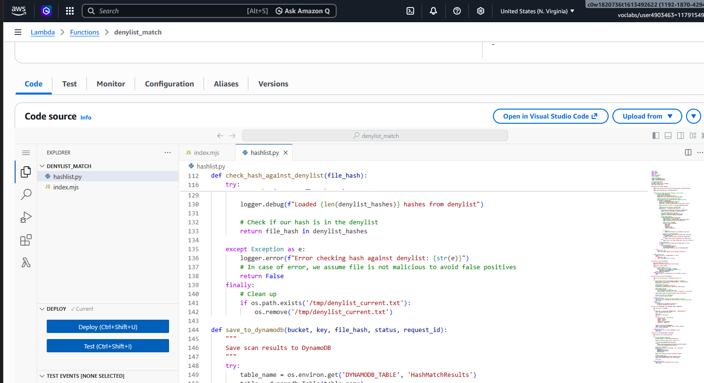

Step 3: Configure Lambda Environment Variables
Set up the required environment variables:
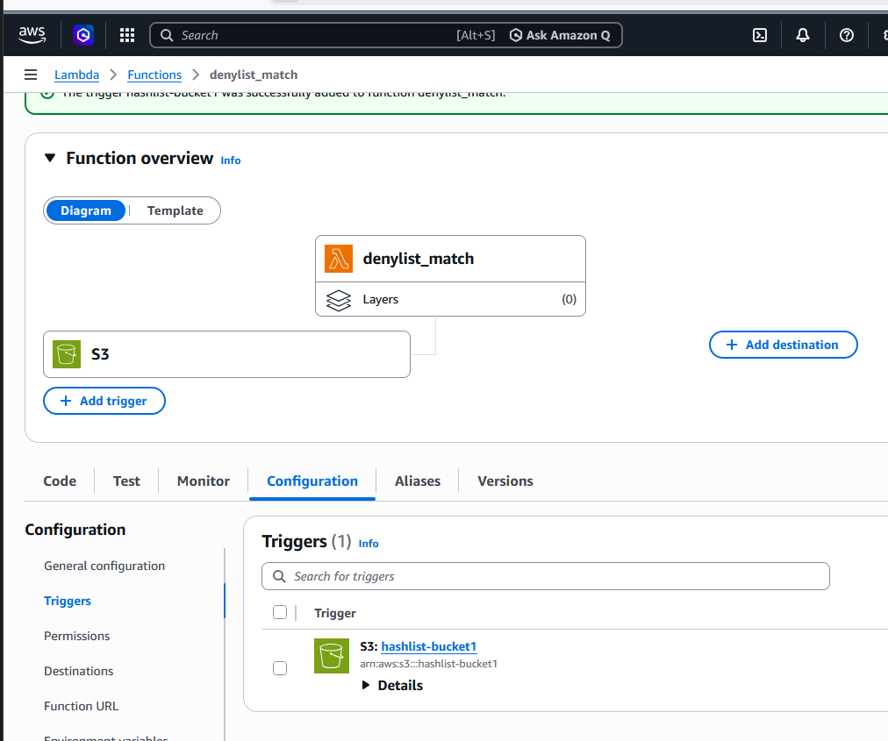

Step 4: Create DynamoDB Table for Results
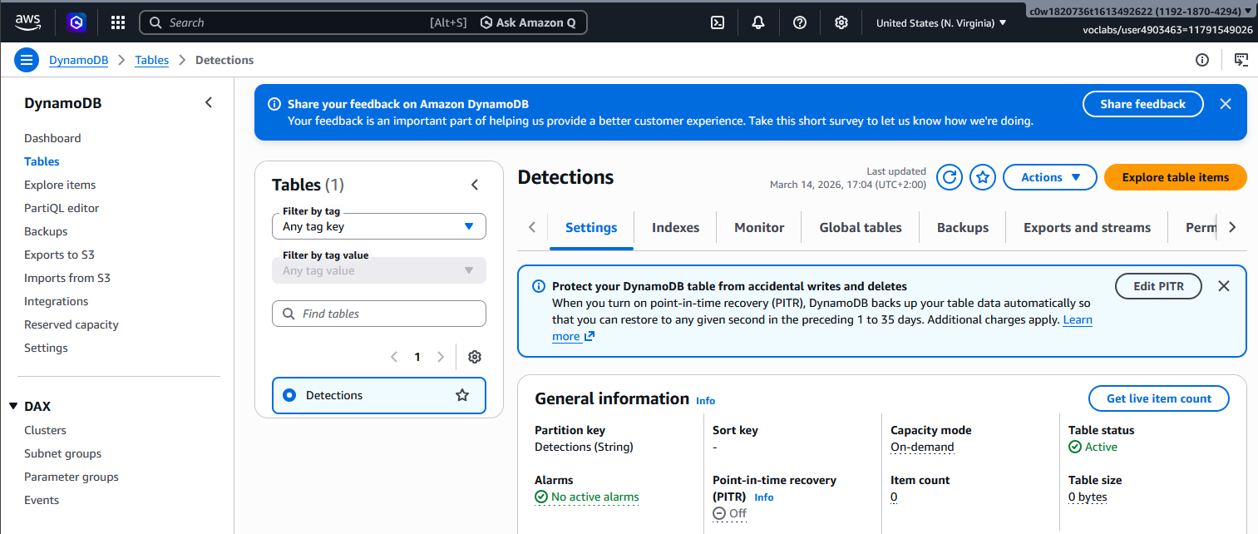

Step 5: Add SQS Trigger to Lambda
Make sure your Lambda is triggered by SQS:
https://sqs.us-east-1.amazonaws.com/119218704294/hashlist
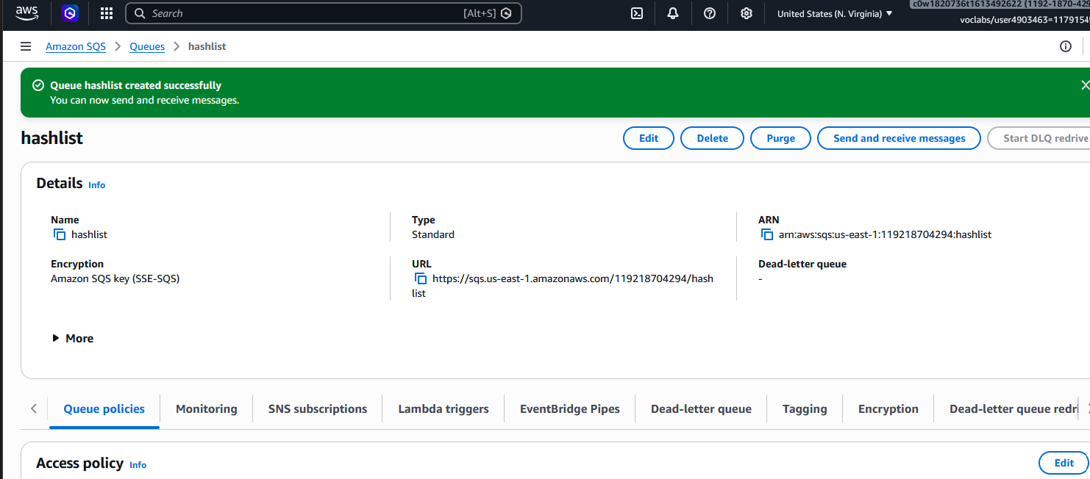

Step 6: Grant Lambda Permissions
need to ensure your Lambda function has the necessary IAM permissions to access S3, DynamoDB, and SQS.
Via AWS Console
- Go to IAM Console → Roles
- Find the role used by your Denylist-parsing-function (usually named something like Denylist-parsing-function-role-xxx)
- Click "Add permissions" → "Attach policies"
- Add these managed policies:
  - AmazonS3ReadOnlyAccess
  - AmazonDynamoDBFullAccess
  - AmazonSQSFullAccess
- Click "Attach policies"

Step 7: Test the Denylist Function Manually
Create a test event to verify the function works:
test-sqs-event.json
# Create test event file
{
"Records": [
{
"body": "{\"Records\":[{\"s3\":{\"bucket\":{\"name\":\"file-scan-upload89\"},\"object\":{\"key\":\"image2.jpg\"}}}]}"
}
]
}

# Invoke Lambda with test event
aws lambda invoke \
--function-name Denylist-parsing-function \
--payload file://test-sqs-event.json \
test-output.json

Step 8: Upload Files to Trigger the Full Pipeline to file-scan-upload89
Now trigger the complete flow:
image1.jpg
image2.jpg
image3.jpg

Step 9: Check CloudWatch Logs for Denylist Match
- Go to CloudWatch → Log Groups → /aws/lambda/Denylist-parsing-function
- Click on the most recent log stream
- Look for entries like:
⚠️ DENYLIST MATCH FOUND: image2.jpg
Malicious hash: e3b0c44298fc1c149afbf4c8996fb92427ae41e4649b934ca495991b7852b855
Saved match to DynamoDB: image2.jpg-1647283945
File moved to quarantine: image2.jpg

Step 10: Verify DynamoDB Results
# Check DynamoDB for hash match results
aws dynamodb scan --table-name HashMatchResults --max-items 10
Expected output:
{
"Items": [
{
"file_name": {"S": "image2.jpg"},
"bucket": {"S": "file-scan-upload89"},
"sha256": {"S": "e3b0c44298fc1c149afbf4c8996fb92427ae41e4649b934ca495991b7852b855"},
"status": {"S": "DENYLIST_MATCH"},
"timestamp": {"S": "1647283945"},
"request_id": {"S": "550e8400-e29b-41d4-a716-446655440000"}
}
]
}

Step 11: Verify Quarantine Bucket
Check if malicious files were moved to quarantine:

Task 6: Complete Architecture Diagram

Project Challenge:

Modify the starter architecture diagram and add it to the template showing evidence of the following elements (you could also include the image file in your submission):
- The flow of file from the User to the file-upload S3 bucket
- Bucket-scan-function Lambda Trigger to scan files through the Yara engine.
- SQS queue message invoking the Denylist-parsing-function.
- Presence of Hashlist in a separate S3 bucket, which the Denylist-parsing-function will read.
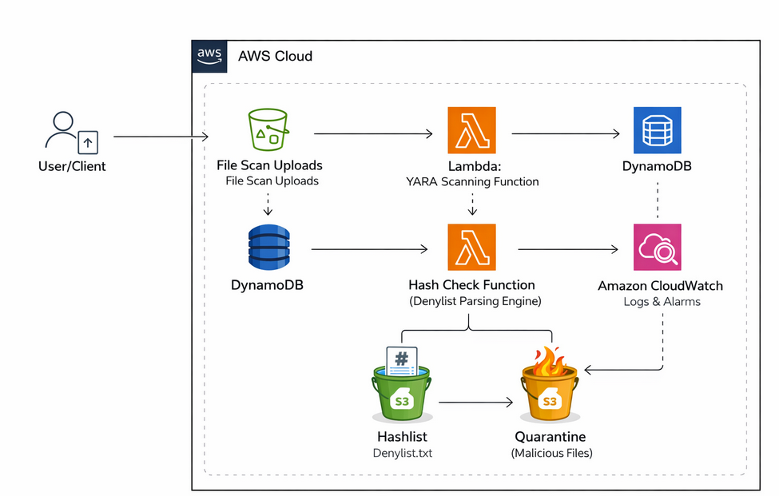

Data Flow Explanation:
- User uploads file → file-scan-upload89 S3 bucket
- S3 Event Notification triggers the Yara scanning Lambda
- bucket-scan-function executes YARA rules against the file:
  - If clean → continues normal processing
  - If suspicious → detection name recorded
- Scan results written to DynamoDB table
- SQS Queue receives message for deeper analysis
- Denylist-parsing-function triggered by SQS:
  - Reads hashlist from separate S3 bucket
  - Calculates file hash
  - Compares against denylist
- Hashlist S3 bucket stores the master list of malicious hashes
- Quarantine bucket (optional) stores confirmed malicious files
Key Architecture Features:
- Decoupled processing using SQS prevents data loss
- Multiple detection layers (YARA + hash denylist)
- Persistent storage of scan results in DynamoDB
- Isolated hashlist for security (separate bucket with restricted access)
This architecture follows AWS best practices for serverless file processing and security automation .
